**Entity Relationship Diagram**

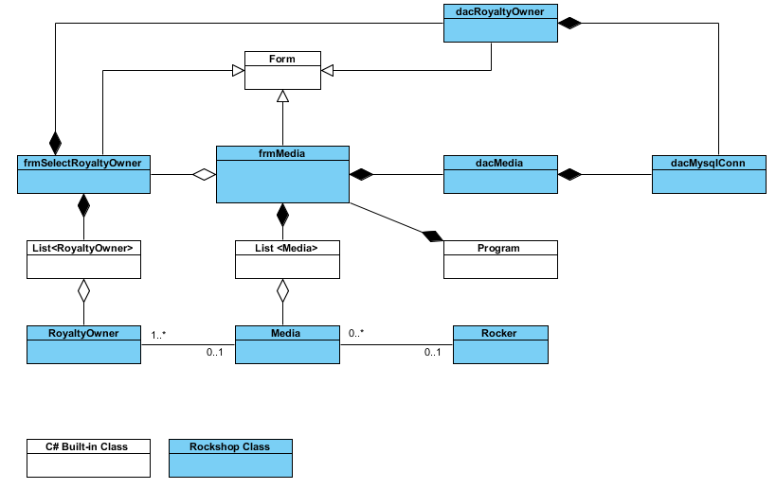

{ details please see Rockshop.vpp }

**Use Case Diagram down to down to and including level 2.**

**Use Case Diagram - Level 0**

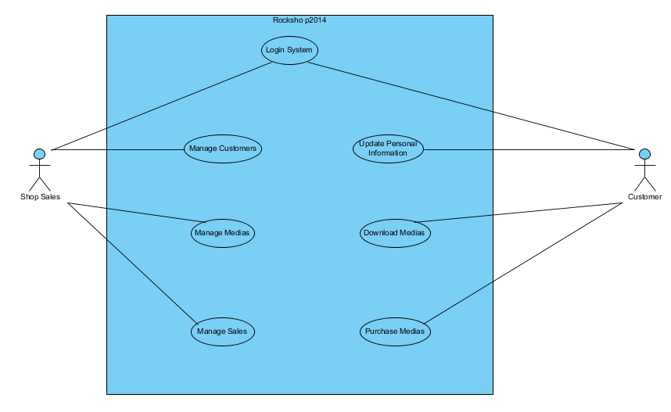

**Use Case Diagram – Level 1**

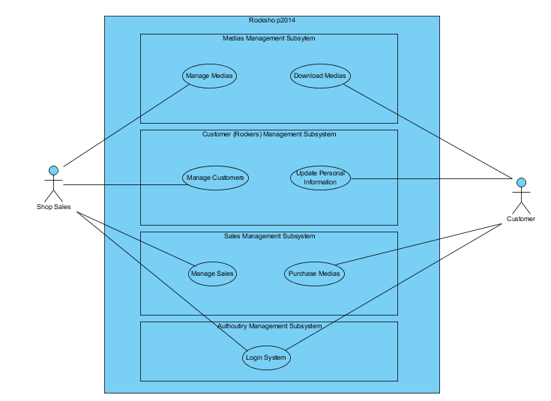

**Use Case Diagram – Level 2**

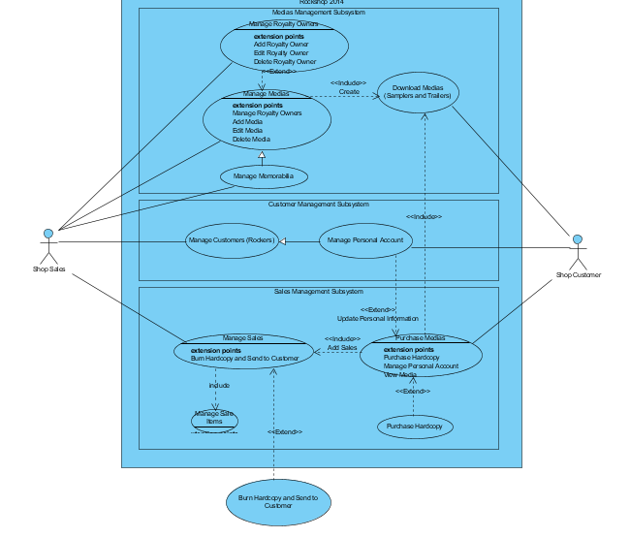

{ details please see Rockshop.vpp }

**Sequence diagrams for each of the following business processes (Insert, Update, Delete and Search)**

**Sequence Diagram - Media**

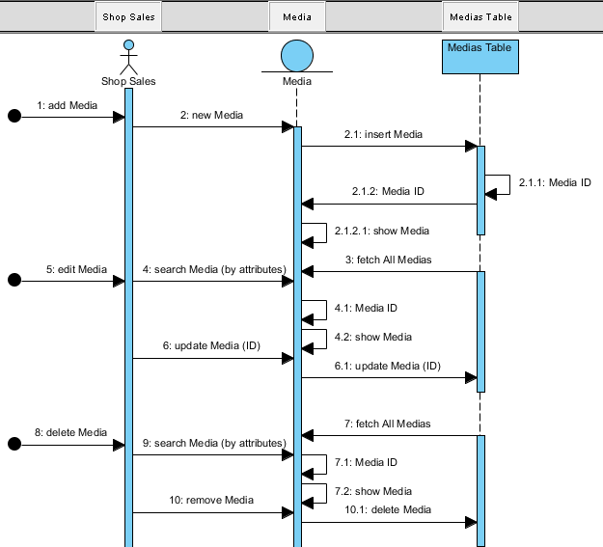

**Sequence Diagram – Rocker**

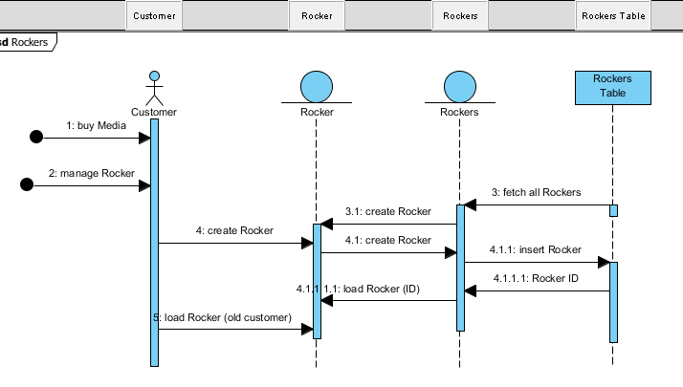

**Sequence Diagram – Sales**

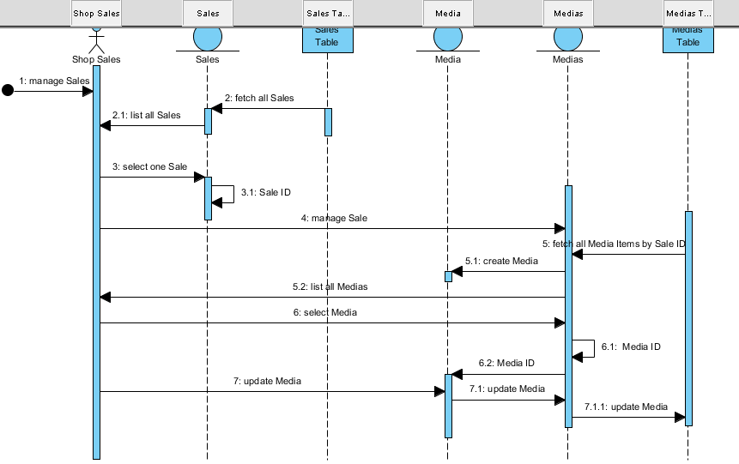

{ details please see Rockshop.vpp }

**Screen design for each of the above business processes.**

Media Management Screen Design as following

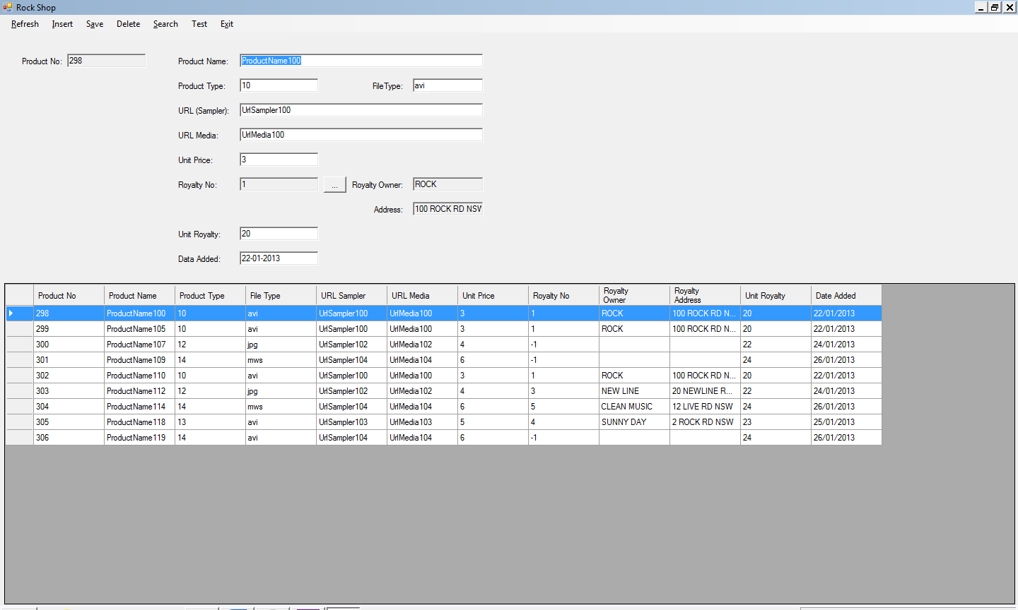

**Use case | Expanded Use Case Scenarios for each of the following business processes**

**Media Management Subsystem**

a) Shop Sales can Manage all Media products (1) at any times. She / he can Add new Media (1.1), Edit existed Media (1.2), and Delete them (1.3).

b) As for Memorabilia type of Media, Shop Sales can manage them as well (2).

c) When Shop Sales manage Medias, they can also set and update the Royal Owner of each Media (3). They can Add new Royalty Owner (3.1), they can Edit Royalty Owner (3.2), and they can remove the Royalty Owner (3.3) from system.

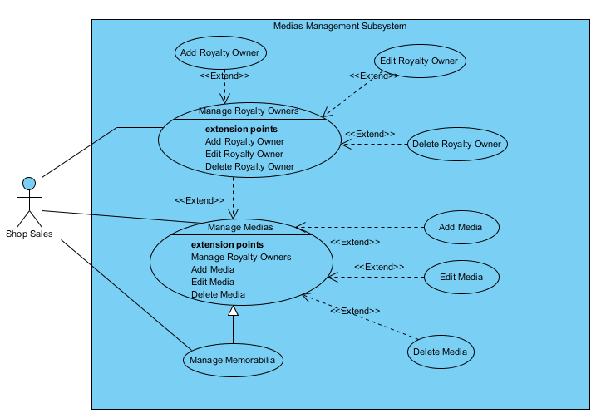

3.3

3.2

3.1

3

2

1.3

1.2

1.1

1

**Royalty Owner Management**

a) As system manager, Shop Sales can manage Royalty Owners when login system. They can add Royalty Owner (1.1), they can remove Royalty Owner (1.2) when necessary, or they can edit Royalty Owner information (1.3) in system.

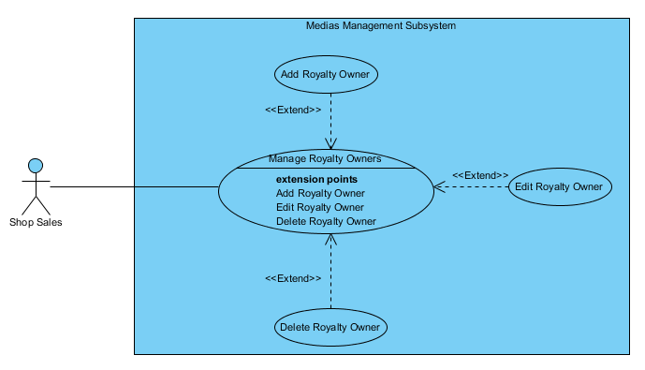

1.2

1.3

1.1

1

**Sales Management**

a) As for Customer, they can Purchase Medias online (1).

b) Before they make up their mind, they can choose to view details of each Media (2.1), they can add Media (2.2) to their shopping cart, vice versa, they can remove Media from the shopping cart (2.3).

c) And also, they can choose to purchase the Hardcopy of each Media (3).

d) As for sales order manager, Shop Sales, they can manage each Sales order (4). They can view all the Medias in each Sales order, they can add Media item to each Sales order (2.2) when in special conditions, and Remove some Medias as well (2.3).

e) As well, when they find customer need the Hardcopy, they should burn Hardcopy and send it to customer (5).

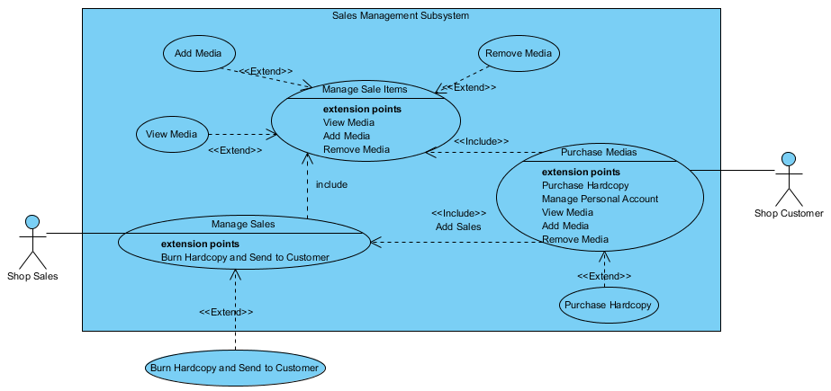

5

3

4

2.3

2.2

2

2.1

1